A Symphony of Fractions
Oriol Pallarés and Carlota Petit

Task 1: Becoming Music Experts

Worksheet 1: Music Jigsaw Reading

Group work

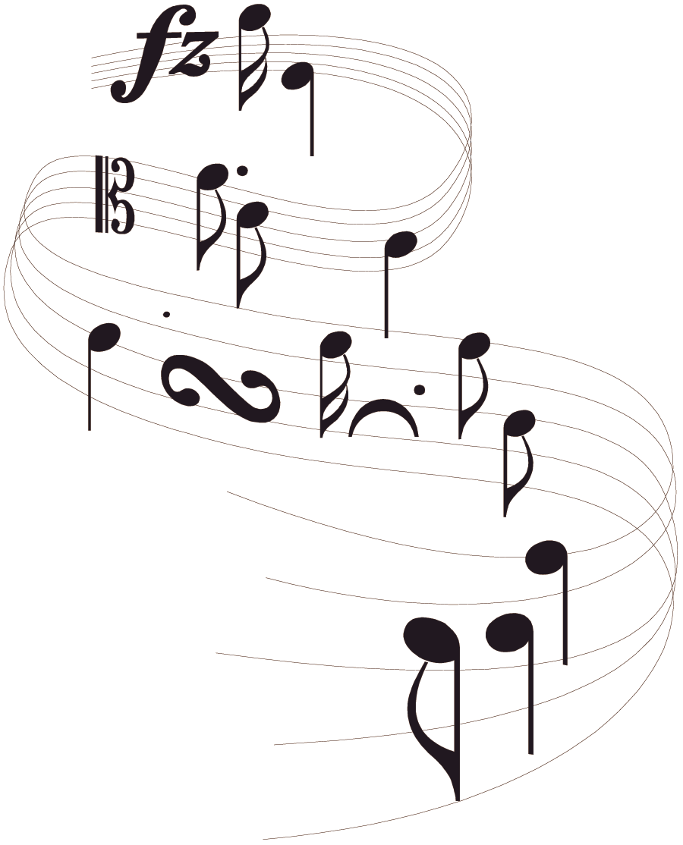
- In groups of five, assign yourselves a number from 1 to 5.
- Read the “expert card” that has your number. Try to understand it and memorize as much as you can.
- Make “expert” groups with the people from the other teams that studied the same expert cards. Once in your expert group, you will see that all of you have the same text.
-  You need to become real experts, so use as many strategies as you can to become more and more familiar with the content of the expert card: one of you explains, the others listen and help, ask each other questions, quiz each other...
-  When your teacher tells you to, work in pairs with someone from your “expert” group. Take turns explaining the text to each other without looking at it. The listener can look at the text and help the speaker.
- Now go back to your original team of four.
-  You will now have some time to share everything you learned with the other members of your team. You are now the only expert of your text in the team, so you have to explain what you have already practiced to the rest of your team mates.
- The objective is that all of you learn the information contained in all the expert cards.
- Your teacher will test you and your team to make sure that you have been working hard.

STUDENT 1: Expert card

HOW IS MUSIC WRITTEN?
Just as language is recorded with a set of letters that represent spoken sounds, music is recorded with a set of symbols that represent musical sounds. This system of symbols, called notation, tells musicians the pitch and the duration of each sound they are to play.

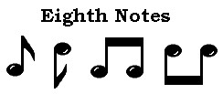
Duration
The longest note is the whole note. Next is the half note, then the quarter note, and so on, up to the sixty-fourth note. Notes with shorter values than the quarter note have flags, or “tails,” on their stems.
The whole note has the same time value as—or equal to—two half notes. A whole note also equals 4 quarter notes, 8 eighth notes, and so on, up to 64 sixty-fourth notes. When two or more eighth notes or shorter notes follow each other, they are often joined.
Breaking a whole note into equal shorter notes can be seen as fractioning it, just as the names of the shorter notes indicate.

Observing the diagram below, we can say that:

Whole note = half note + half note = quarter note + quarter note = etc.
w= h+ h= q+ q+ q+ q = e+e+e+e+e+e+e+e = etc.
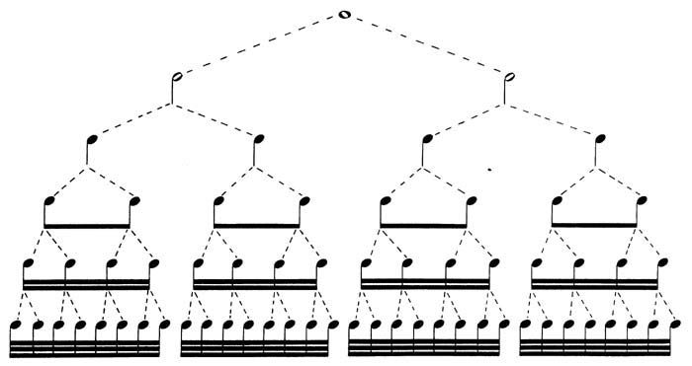
Whole note
Half note
Quarter note
Eighth note
Sixteenth note
Thirty-second note

1 =$1=\frac{1}{2}+\frac{1}{2}=\frac{1}{4}+\frac{1}{4}+\frac{1}{4}+\frac{1}{4}=...$
STUDENT 2: Expert card

Did you know...

…that there are two systems for naming note values in the English language. Here, the American names are listed first and the European names are listed in parentheses.

- Whole note (semibreve)
- Half note (minim)
- Quarter note (crotchet)
- Eighth note (quaver)
- Sixteenth note (semiquaver)
- Thirty-second note (demisemiquaver)
- Sixty-fourth note (hemidemisemiquaver)

Rests
When there is to be no sound, a rest is used. Rests have the same time value as notes of the same duration, ranging from a whole rest to a sixty-fourth rest.

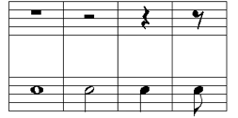
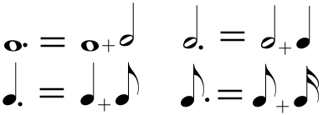
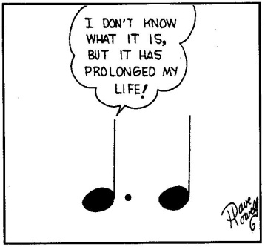
Dotted notes
A dot after a note increases its duration by one half. Thus a quarter note followed by a dot lasts one quarter note plus one eighth note. Duration is also increased by the tie, —a curved line connecting a note and the repetition of it. The tie makes the total duration of a note equal to that of the notes connected.
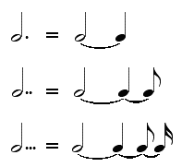

STUDENT 3: Expert card

Time signature

The time signature (also known as the “meter”) is a notational convention used in Western musical notation to specify how many beats are in each measure and what note value constitutes one beat.
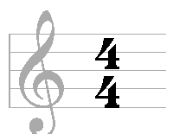
Most time signatures comprise two numbers, one above the other. Time signatures are written like a fraction
This time signature expresses that there are 4 beats in a measure and that the value of each beat is “1/4” of a whole note.

Did you know…?

…that note values have nicknames that we can use to say the rhythms with our voices. Each language has its own words.

Power | Result | Sign
q | ta | quarter note
N | ti-ti | 2 eighth notes
Q | sshh | quarter note rest
y | tika-tika | 4 sixteenth notes
H | too | half note
M | ti-tika | eight note and 2 sixteenth notes
M | tika-ti | 2 sixteenth notes and an eighth note
je | tum-ti | dotted quarter note and eighth note
eqe | syn-co-pa | eighth note, quarter note, eighth note
o | tim-ka | dotted eighth note, sixteenth note

STUDENT 4: Expert card

Did you know...

...that when you join three equal notes, we call this “a triplet” and its value is the same as the value of two of the notes? In other words, you play three notes in the normal time of two notes, but you need to play the three notes for the equal amount of time. Each note is 2/3 of the value of the triplet.
t = n
T= ss
So if t = n, we need to be careful when operating with notes. It is obviously not the same $\frac{3}{4}≠\frac{2}{4}$. Therefore, when we operate with triplets, we will need to take the value of the figure, but not the value of each of the notes that make the figure; or in math words, we will use 2 in the numerator instead of 3.

Did you know...

…that in music, when we play three notes one after the other, having the one in the middle twice the value of the other two, we say the rhythm is syncopated. The rhythm sounds abrupt because we are stressing a part of the rhythm that is not usually stressed.
eqe or qhq

Syncopation is used in many musical styles, if not all, and is fundamental in such styles as funk, ska, reggae, ragtime, rap, jump blues, jazz and often in heavy metal, and classical music.

STUDENT 5: Expert card

Did you know...

…that there are different ways singers / vocalists / musicians use to express musical notes?

- Letter names give a label to each note: C D E F G A B. These are the letter names used in English, Dutch, and possibly a few other languages.

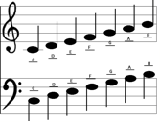

- However, Germany, Scandinavia (such as Iceland, Denmark, Sweden) and Slavic countries have another system: their C major scale is C D E F G A H. Their H corresponds to B in the English system.

- In some countries such as Spain, Portugal and France, solfege is always used instead of note names.

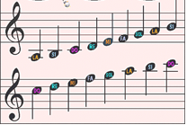

Task 2: Languages in the Worlds of Math and Music 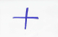

Worksheet 1: Languages and Cultures in Tune

Pair work
- As you have seen, in this project we are not only becoming music experts but also learning about different languages and cultures. Would you be able to tell us which languages and cultures have been mentioned in Worksheet 1?

- Look at the following word enigma and list the languages and different cultures we have been dealing with so far.

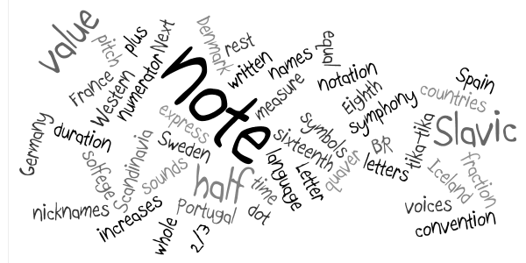

Group work
- Allegro, π, mezzo forte, ß, lied,…

- Do you know why these important music terms are in Italian?
- Can you think of languages and cultures that are important in the world of music? And in the world of math?
- Do you know any great musicians and mathematicians? Where do they come from?

 Discuss these questions in groups.

To answer this question, we encourage you to go online and do some research on the history of music and the history of math. Some key words you may want to use are: history of music / history of math / great musicians / Italian in music / etc.

Group work Whole class
-  You are now ready to prepare a short oral presentation of your findings. Here are some expressions you may want to use. While each group is presenting, your teacher will make a mind map on the board with everybody's findings.

Some expressions for your oral presentation:
- …...... are important words in the world of music....
- We have found that ….. / We have learnt that... / We know that...
- (musician/mathematician) is famous for his/her …...... /(musician/mathematician) is famous because......
- (musician/mathematician) comes from …..
- Italian is important in the world of ….. because....
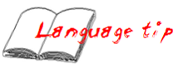
- Some examples of music/mathematics words in (language) are....
- The word ….. means …..

Group work
-  In some of the expert cards some languages and cultures are mentioned. In teams, take one of the languages you consider important in the world of music, and make a new expert card which contains new relations between music and/or math and the new language you have chosen.

You can choose English, but we encourage you to choose a different language (maybe one of the languages you found when you did some research for activity 2).

Group work
- What about your mother tongue? And what about other languages you know? Taking everything you have learnt in this first and second part of the project (Worksheet 1 and 2), think of how many of these new music and math concepts you can say in the languages you know. Make a word cloud like the one in activity 1, using all the languages you and your teammates know. You can use the online tool Worlde (www.wordle.com).

Task 3: Composing a Shymphony of Fractions

Worksheet 1: Applying math to make music

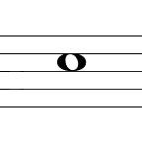
As you have learnt, note values express the duration of a note or a rest. This duration can be expressed as a fraction of a whole note.
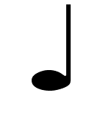
For example: ¼ of a whole note is = (a quarter note)

Group work

-  Try to decipher the secret rhythm and write the corresponding note values.
The time signature of the music line is , so don’t forget to write the measure lines.
Use the following fractions in this order. You can choose two of the fractions to make them rests.

$$\frac{2}{8}+\frac{1}{4}+\frac{1}{2}+\frac{4}{16}+\frac{4}{16}+\frac{1}{2}+\frac{3}{8}+\frac{1}{2}+\frac{1}{4}+\frac{2}{8}+\frac{1}{4}+\frac{4}{16}+\frac{1}{4}$$

- How many measures does each of the music lines have?
- What fraction represents the addition of all the note values of each of the measures?
- What is the total duration of the rhythm? Remember that here.$\frac{3}{8}=\frac{2}{8}$

- Clap the secret rhythm or use the rhythm nicknames you learnt.

Pair work

-  Now we want you to create a different rhythm. But this time you will need to use your musical creativity. The time signature will be again. And the total duration of the rhythm has to be the same as the rhythm above.

These are the values you must use and the minimum number of times you should use them :
Note value | Number of times
Whole notes | 1
Half notes | 1
Quarter notes | 3
Eighth notes | 6
Sixteenth notes | 8
Syncopation | 1
Triplet | 1
Dots | 1

- Clap both rhythms at the same time. Then, say the rhythms using the note value’s English nicknames and later your own language note value’s nicknames.

Group work and whole class

- Then, give your rhythm to the other teams and get their rhythms. We are now going to challenge you to play two or three or more rhythms at the same time, so get together with another pair of students and play a few rhythms. Remember that a symphony is playing different parts at the same time.

Worksheet 2: Writing your Symphony of Fractions

Pair work

- Download a trial version of a music notation software and write your “symphony of fractions” using music notation, words, symbols… You will find a lot of music notation programs on the Internet.

- Convert your symphony to mp3 format and upload it to the net to share it with the world. Your teacher will tell you where to post your work.

Extension

- If you play a musical instrument, play one or more rhythms.
- Choose a language you know and write some lyrics to sing along with your tune.

